Minutes of Meeting
5th Consortium General Assembly

Meeting Date: | 31st October 2019
Meeting Location: | Buttrio (Udine) - Italy
Meeting requested by: | Coordinator
Purpose, Objectives and Elements of the Meeting with ref to WPs and relevant tasks (as per Meeting Agenda) | 5th Consortium General Assembly and 10th Executive Board Meeting
Minute prepared by: | S. Angelini – Luciano Manzon - NAVALPROGETTI
Attendees approval Date :
Attendees: | - NAVALPROGETTI: Loris Cok, Spartaco Angelini, Luciano Manzon, Oscar Perosa  - DOW: Oksana Pilatova, Frederik Bauknecht  - DOWAKSA: Not present  - PNO: Ron Weerdmeester, Oscar Smulders, Greta Giedraitytè, Chiara De Marco  - VTG: Borys Victorovich Shvets  - SINTEF OCEAN: Agathe Rialland, Lars Magne Nonas, Halvor Lie  - BM Plus: Francesca Bozzi, Giuseppe Monteverdi, Paolo Maschio (only Morning)  - CNGV: Giovanni Fratti, Martin Meze  - CENERGY: Michele Capobianco, Tancredi Chinese, Malabotti Stefano  - HLL: not present  - CHC: Nicolas Droushiotis  - ESTECO: Alberto Clarich, Rosario Russo, Zhongli Wen, Luca Battaglia  - ABS: Stavros Niotis
Summary of Significant Results | The assembly starts at 0900 – The assembly is valid and the meeting agenda approved.  0900 – 1030: Consortium partners visited the different components of the pilot line guided by Giovanni Fratti and Giuseppe Monteverdi. In particular the liner fully wrapped with carbon fiber, the winding machine, the hydroforming equipment and the fatigue, autofrattage and burst test appliances.  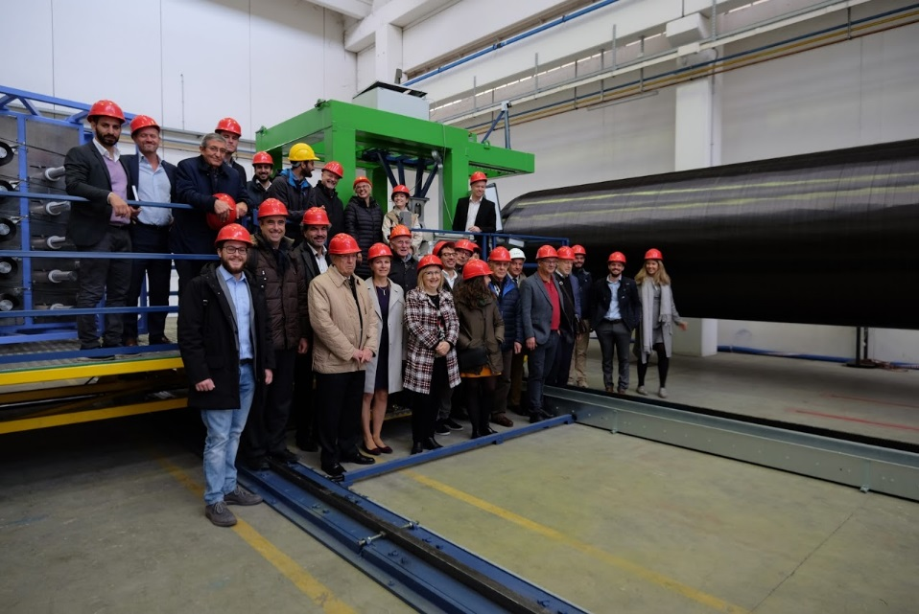  On board the winding machine and near the firstly wrapped cylinder  1030: Welcome address to attendees of coordinator Loris Cok and starting of assembly works at delParco Hotel in Buttrio (Udine).  With reference to the presentation, with relevant conclusions submitted the day before during the WP7 and 9 progress meeting by the partner CHC, the coordinator emphasizes the need to follow the time schedule of the activities so that the contents and conclusions presented are fully shared and supported by the WP7 partners with sound and reliable inputs. This could happen only when the deliverable D7.2 will reach a satisfactory progress in the course of the next months.  Regarding the CHC doubts about the validity of the diagrams in Figure 1.4 of the technical part of the Grant Agreement it shall be noted that said diagrams exist in several versions and from several reliable sources on the web. For example, here below is reported the diagram presented in 2015 at www.carbonlab.eu by professor Constantinos Hadjistassou – Nicosia University - Cyprus  that must be known to partner CHC and where the viability limits of CNG are clearly defined. In any case and after all, such type of diagrams represents only the starting point of the GASVESSEL research programme and the validity of the diagrams’ assumptions are going to be validated by D 7.2 results.  Partner DOWAKSA needs to appoint a new representative in the Executive Board. In the absence the coordinator will propose to the assembly for approval a new member of the Executive Board.  WP1: See presentation. The project is progressing according to the expectations, both on the technical point of view and with respect to the sustained costs with the only possible exception for BM Plus for which remedial mitigations are under consideration by the coordinator.  Partners are informed about the initiative of the Australian company GEV regarding CNG waterborne transportation (4 ships object of a LOI).  WP2: the deliverable D2.1 is considered by EU as live document. Partner CHC is engaged to issue an updated document within the current month of November. Coordinator will ask PO to re-open in due time the portal for uploading the revised document.  CHC representative hurried up partners to decide and inform him as soon as possible about the intention to attend the next gas event of April in Nicosia.  WP3: The design activities of the experimental pilot line have been completed and the results obtained have been shown in working conditions to the partners, as mentioned above.  WP4: See presentation. In addition, BM Plus presented a short video relevant to the hydroforming operations.  WP5: See presentation: no comment from the partners.  WP6: See presentation; NP explains the method of calculations used to identify the cost of storage required both on loading and unloading sides, based on the estimated cost evaluation of a certain number of 40” cylinders, to obtain the requested storage capacity.  CHC suggests using the loading and unloading configuration developed for Barents Sea also for East Med scenario.  WP7: See presentation. It is suggested and accepted to anticipate as soon as possible the first results of the analysis relevant to the D.7.2., in order to have the necessary time for their evaluation, confrontation and fixing final figures. Regarding the task 7.3. SINTEF needs some help from the partners: for the purpose dedicated meetings will be arranged in due time.  Deliverable D.7.1. uploaded on EU portal on October 31^{st.} according to the schedule.  SINTEF presented the study as well on the Dynamic Positioning and necessary mooring appliances relevant to the smallest ship fitted also with the bow loading/unloading.  WP8: See presentation: ABS inform the partners about the CNG projects on which ABS is involved. ABS point out that the final output of tests on CNG cylinders will lead to the issuance of a “Product Design Approval”; the manufacture approval will take place on a future industrial production line. NP will supply ABS with the revised cylinder testing schedule to allow ABS planning its attendance.  WP9: See presentation. Starting from the January 2020, when the project activities on the experimental pilot line will be concentrated on the final tests, it will be necessary to intensify the partner efforts on dissemination and exploitation activities. Regarding the need of issuing at least 8 scientific publications, the partners are invited to send their proposals (title and small abstract) to NP and PNO within the end of December. As far as the third workshop, DOW suggests organizing it in the course of an important international context, taking advantage of the presence of the most important potential stakeholders. PNO and NP, with the help of the other partners, will contribute to the organization of the workshop. PNO will assist the partners in suggesting and preparing the 6 business cases requested.  CENERGY: See presentation.  ESTECO: See presentation.  Assembly closed at 0630 p.m.
Action Decided
Action Item | Partner Responsible | Due Date
1.Update deliverable D.2.1. | CHC | End November 2019
2.Revised Cylinders Test schedule to ABS | BM Plus | 11 November 2019
3. Meetings calendar for D.7.2.and D.7.3. | SINTEF | End November 2019
4. Abstract for Scientific Publication | All partners | End December 2019
5. Proposals for third workshop | All partners | End January 2020
6.Inputs for 6 business cases | All partners | End January 2020
7. Finalize the partners active presence at dissemination events | PNO coordination | End January 2020 for events planned on year 2020
8. Special studies (gas leakages, etc.) | ESTECO, NP | 6 November 2019
List of Attachments: | Partner presentations delivered with separate email

The meeting is valid according to the Consortium Agreement Statements. The General Assembly is also valid as 10th Executive Board meeting.
Next General Assembly in Buttrio, on March 2020 (date TBD).

